Project Overview
Market Research Insight ek RAG-based commodity research application hai jo market news ko ingest, clean, embed, retrieve aur LLM ke saath synthesize karta hai. Ye application analyst-grade supply/demand insights generate karta hai Streamlit UI se user input lekar.
- Technology stack:
  - Python 3.10
  - Streamlit frontend (app.py)
  - Requests + BeautifulSoup for news retrieval
  - SentenceTransformers embeddings
  - FAISS vector index
  - Google Gemini / GROQ / local HuggingFace LLM
  - dotenv config
  - Logging via logging + rotating file
- Design philosophy:
  - Modular RAG pipeline
  - Fail-safe retrieval / fallback
  - Clean separation: retrieval, cleaning, chunking, embedding, retrieval, generation
  - Disk-first persistence for repeatability
  - Easy provider swap via config
- Folder structure:
  - src: core logic modules
  - data: corpus, embeddings cache, FAISS index, insights
  - logs: runtime logs
  - model: optional local model artifacts

High Level Architecture

System Components
Frontend
- Purpose: user interaction aur report display
- Responsibilities:
  - Input capture for metal/country/price/change
  - Progress update
  - Display final insight, supply/demand sections, retrieval evidence
- Input: user market query
- Output: rendered report
- Dependencies: Streamlit, run_pipeline
- Error handling: UI shows stage error if pipeline returns failure
Backend
- Purpose: pipeline orchestration
- Responsibilities:
  - Input validation
  - Stage progress
  - Result composition
- Input: validated market parameters
- Output: summary, supply/demand insights, retrieval evidence, stats
- Dependencies: src.pipeline, src.validators
- Error handling: catches exceptions and returns structured error message
Core Engine
- Purpose: actual RAG workflow
- Responsibilities:
  - News ingest
  - Cleaning
  - Chunking
  - Embedding
  - Indexing
  - Retrieval
  - Prompt generation
- Input: validated user query and domain context
- Output: retrieval candidates + LLM prompts + generated text
- Dependencies: news_retriever.py, data_cleaner.py, chunker.py, embeddings.py, faiss_manager.py, retriever.py, prompts.py, llm_engine.py
- Error handling: stage-specific try/except with logging and fallback warnings
Database / Storage
- Purpose: persistent corpus, index, cache
- Responsibilities:
  - store cleaned JSON corpus
  - persist FAISS index and metadata
  - cache embeddings
- Input: processed text artifacts
- Output: reusable storage for retrieval
- Dependencies: filesystem, config.py
- Error handling: disk save/load exceptions logged
LLM
- Purpose: final insight generation
- Responsibilities:
  - talk to Gemini / GROQ / local model
  - generate supply, demand, summary text
- Input: assembled prompt
- Output: natural language insight
- Dependencies: google.generativeai, groq, transformers
- Error handling: provider-specific exceptions caught and logged; user-facing fallback string on failure
Vector Database
- Purpose: semantic similarity search
- Responsibilities:
  - build FAISS index
  - store vectors and metadata
  - return top-k relevant chunks
- Input: embeddings + metadata, query vector
- Output: scored retrieval results
- Dependencies: FAISS
- Error handling: index corruption detection, rebuild fallback
External APIs
- Purpose: news sourcing
- Responsibilities:
  - fetch NewsAPI articles
  - scrape SteelOrbis
- Input: metal/country query
- Output: raw article list
- Dependencies: requests, BeautifulSoup
- Error handling: retries, timeout handling, graceful fallback if one source fails
Monitoring
- Purpose: runtime observability
- Responsibilities:
  - log pipeline stages
  - log errors/warnings
- Input: stage events
- Output: log files and console output
- Dependencies: logger.py
- Error handling: logger writes fallback on IO errors
Evaluation
- Purpose: inspection of RAG evidence
- Responsibilities:
  - expose retrieval context for review
  - support human audit of outputs
- Input: retrieval results
- Output: evidence panel in UI
- Dependencies: frontend expansion panel
- Error handling: missing evidence handled with fallback messages
Configuration
- Purpose: centralized settings
- Responsibilities:
  - load .env
  - define paths and hyperparameters
- Input: environment variables
- Output: runtime constants
- Dependencies: python-dotenv
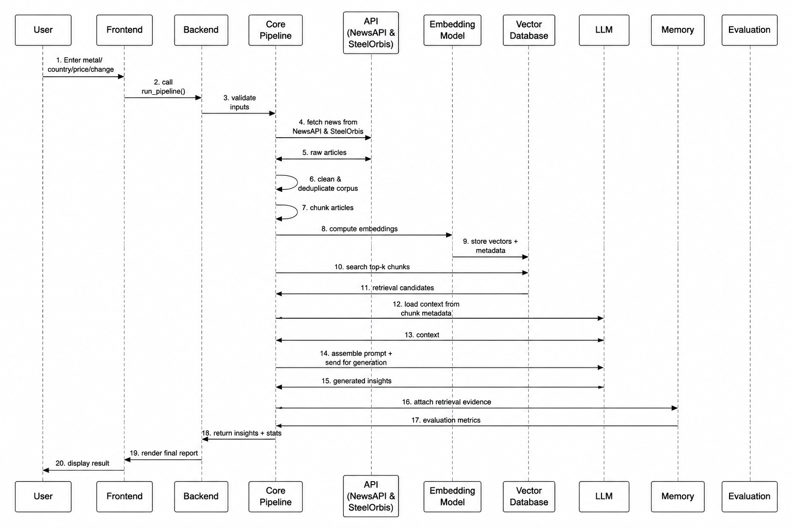
Data Flow—diagram

Search Pipeline
Input
|
v
Preprocessing
|
v
Embedding
|
+--> Vector Search
| |
| v
| Vector Candidates
|
+--> Keyword Search
| |
| v
| Keyword Candidates
|
v
Hybrid Fusion
|
v
Filtering
|
v
Re-ranking
|
v
Final Ranking
|
v
Response

AI Pipeline
- Prompt Generation
  - prompts.py se supply, demand, summary templates banate hain.
  - User market data aur retrieved context prompt mein inject hota hai.
- Context Retrieval
  - query vector embed karke FAISS search chalaate hain.
  - top chunks metadata ke saath milte hain.
- Memory Retrieval
  - chunk text + article metadata ko “memory” context maana jata hai.
  - Agar corpus local file se load ho toh usko memory retrieval ke roop mein use karte hain.
- Prompt Assembly
  - selected supply/demand chunks ko structured context mein format kiya jata hai.
  - Market metrics add kiye jate hain.
- LLM
  - configured provider (gemini, groq, ya local) ko prompt bheja jata hai.
- Post Processing
  - response ko trim aur clean kiya jata hai.

- Post Processing
  - response ko trim aur clean kiya jata hai.
  - agar output prompt copy kare toh prompt removal apply hota hai.
- Response Generation
  - final output app.py ko return hota hai.
  - UI mein executive summary, supply, demand, aur evidence panels show hote hain.
Folder Architecture
/
|-- app.py
|-- README.md
|-- requirements.txt
|-- configs/
|-- data/
| |-- corpus/
| |-- embeddings_cache/
| |-- faiss_index/
| |-- insights/
|-- logs/
|-- model/
|-- src/
|-- __init__.py
|-- chunker.py
|-- config.py
|-- data_cleaner.py
|-- embeddings.py
|-- faiss_manager.py
|-- llm_engine.py
|-- logger.py
|-- news_retriever.py
|-- pipeline.py
|-- prompts.py
|-- retriever.py
|-- validators.py

Folder explanations
- app.py
  - Streamlit UI entry point
  - controls user interaction and displays results
- README.md
  - project overview, installation, run instructions
- requirements.txt
  - Python package dependencies
- configs
  - placeholder for external config or future YAML/JSON settings
- corpus
  - cleaned article JSON files
  - source corpus archive for provenance
- embeddings_cache
  - cached embeddings by text/model hash
  - speeds up repeated embedding requests
- faiss_index
  - serialized FAISS index and metadata

  - vector search persistence
  - insights
  - generated outputs or reports for later inspection
  - logs
  - runtime logs, error traces, stage information
  - model
  - optional local HuggingFace model files
__init__.py
  - package marker
  - chunker.py
  - chunking logic with semantic splitting
  - config.py
  - environment and path management
  - hyperparameters and provider settings
  - data_cleaner.py
  - HTML stripping, normalization, dedupe, metadata extraction
  - embeddings.py
embedding model loading, batching, cache, query embedding
  - faiss_manager.py
FAISS index lifecycle, persistence, search
  - llm_engine.py
multi-provider LLM interface and provider fallback
  - logger.py
centralized logger configuration
  - news_retriever.py
NewsAPI + SteelOrbis retrieval, retries, graceful degradation
  - pipeline.py
full RAG orchestration and stage control
  - prompts.py
analyst-grade prompt templates
  - retriever.py
semantic retrieval, classification, supply vs demand grouping
  - validators.py
input validation and user-friendly errors
  - API Architecture
Current design
- Current entry point: Streamlit UI in app.py
- Backend call: run_pipeline() in pipeline.py
- There is no formal REST API defined yet, but architecture aligns with API-style request flow.
Request flow
- User submits market details
- Frontend validates input locally
- Backend receives request and runs run_pipeline
- Pipeline validates again in validators.py
- Data retrieval, processing, generation happen
- Response returns with
- supply_insight
- demand_insight
- summary
- retrieval_results
- stats

Response flow
- Structured response dictionary
- UI renders insights and evidence panels
- Errors return a clear status: error + message
Authentication / Validation
- Current implementation: no API auth
- Config uses .env for provider keys
- Recommended future API layer:
  - bearer token or API key validation
  - rate limiting
  - request schema validation
  - metric instrumentation
Error handling
- Validation errors returned before expensive work
- Retrieval failures degrade gracefully
- LLM errors produce fallback response text
- Pipeline exceptions logged and surfaced as stage failure
Database Architecture
Storage model
- Not relational; file-backed artifact store
- Primary storage:
  - data/corpus/*.json → cleaned documents
  - data/faiss_index/faiss.index → vector index
  - data/faiss_index/metadata.pkl → metadata store
  - data/embeddings_cache/*.pkl → embedding cach
Tables / Indexes / Metadata
- FAISS index
  - stores vector embeddings
  - uses Inner Product for cosine similarity
- metadata.pkl
  - parallel list of metadata dicts
  - each entry includes source, published_at, url, metal, country, chunk_text
- corpus files
  - JSON list of cleaned articles with structured fields
Cache
- Embedding cache keyed by text + model
- avoids recomputing embeddings for identical text
Relationships
- Each vector in FAISS corresponds to one metadata entry
- Metadata includes chunk_text, allowing response reconstruction
- Corpus files are the source for chunk generation
- Embedding cache is independent but reused by same text/model pairs
RAG Architecture
- Document Loader
  - news_retriever.py pulls raw articles
- Cleaning
  - data_cleaner.py strips noise and deduplicates
- Chunking
  - chunker.py splits docs into overlapping semantic chunks
- Embedding
  - embeddings.py computes and normalizes vectors
- Vector Database
  - faiss_manager.py stores vectors + metadata
  - retrieve_and_classify searches top-k
- Hybrid Search
  - vector similarity plus keyword classification to label supply/demand
- Prompt Builder
  - prompts.py assembles domain-aware analyst prompts
- LLM Response
  - llm_engine.py generates final narratives
- Evaluation
retrieved evidence surfaced in UI for audit
summary plus retrieval context supports inspection
AI Agent Flow
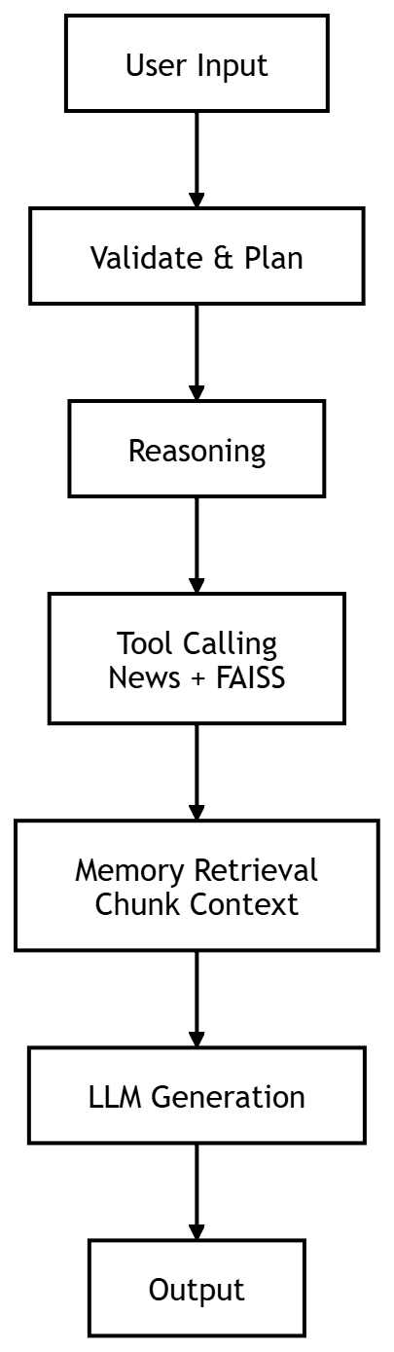
Deployment Architecture Local
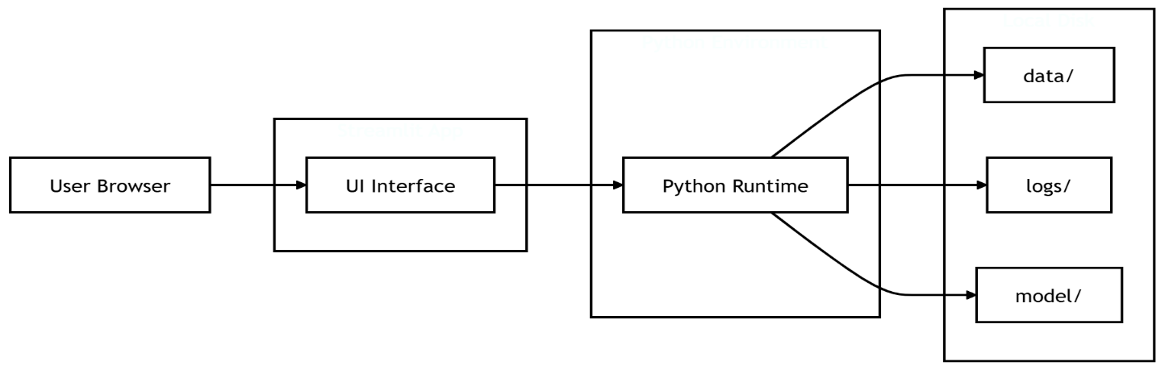
Docker
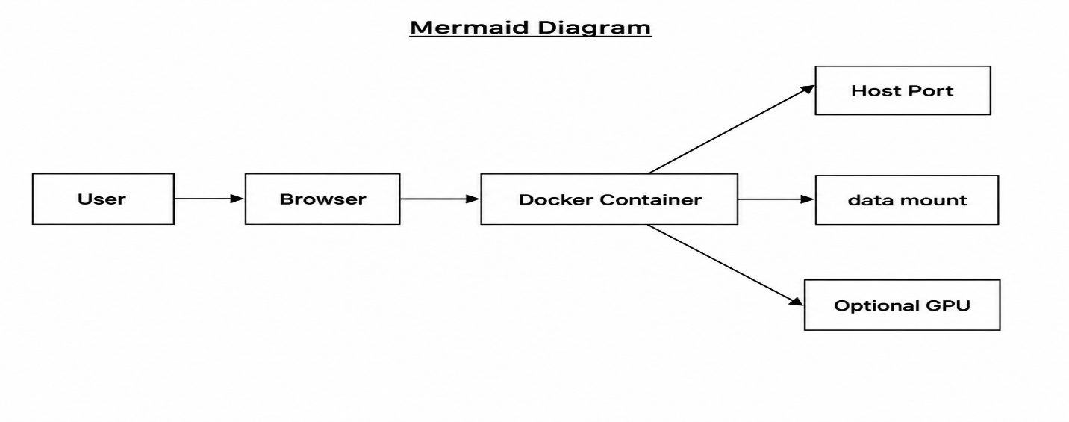
Cloud / Kubernetes
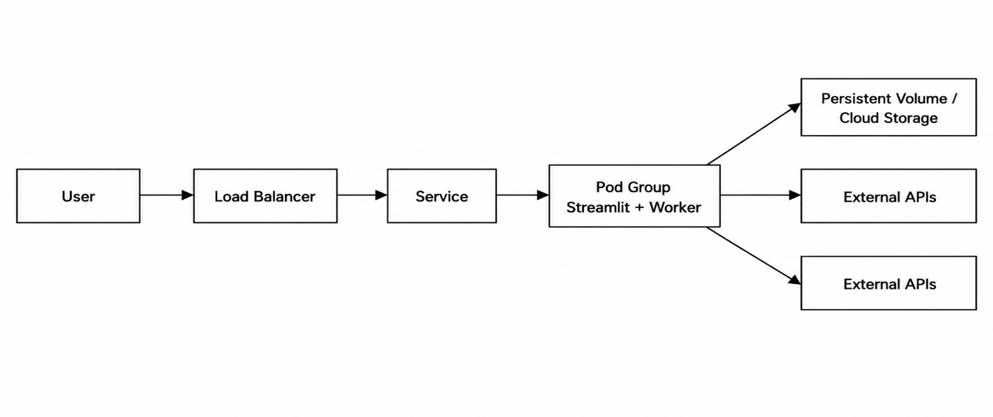
Security Architecture
- API Keys
  - GEMINI_API_KEY, GROQ_API_KEY, NEWS_API_KEY in .env
- Authentication
  - currently absent for UI
  - future API layer should add token-based auth
- Authorization
  - no role model today
  - recommended: restrict access to insight generation endpoints
- Secrets
  - store in environment variables
  - do not commit .env
- Rate Limiting
  - external API calls already limited by provider
  - recommended: app-level rate limiter for users
- Logging
  - error logs and warning logs captured in logs
  - important for audit and incident response
Monitoring
- Logging
  - centralized logger via logger.py
  - stage-level info and error logs
- Metrics
  - counts of raw/cleaned articles, chunks, retrieval hits
- Tracing
  - stage duration tracking possible in pipeline.py
  - future: request IDs and distributed traces
- Alerts
  - on pipeline failure, no data retrieved, or LLM error
- Dashboard
  - current UI shows process progress
  - future: Grafana or Streamlit admin dashboard
Scalability
- Horizontal scaling
  - separate frontend from pipeline workers
  - multiple worker instances for embedding/search
- Caching
  - embeddings cache avoids repeated compute
  - FAISS index reuse reduces cold-start cost
- Workers
  - async ingestion / embedding queue
  - background refresh of news corpus
- Queue
  - future architecture can add Celery / Redis for task orchestration
- Streaming
  - long-running LLM generation can be streamed to frontend
  - current app is synchronous but can be extended
Notes
- Project currently uses FAISS for vector search, but architecture is ready for Pinecone / cloud vector DB substitution.
- config.py centralizes provider selection and path management.
- pipeline.py is the orchestrator that binds all components into a reusable end-to-end flow.

